Executive Summary

This feature streamlines content attribution by enabling users to link their written content to saved sources within the project. It offers a right-click menu for quick access to attribution functions, including text highlighting and source search. By addressing pain points such as scattered source management and manual hyperlinking, it enhances workflow efficiency, saves time, and provides clarity on utilised sources, ultimately improving the content creation process for media and researchers.

Target Release | 2-3 weeks
Epic | Documents
Document Status | {READY}  Figma Link
Owner | Oscar Souchaud

Objective
The purpose of this feature is to allow users of the product to attribute content to sources they have saved to the same project. This fits into our strategic goals as it will enable users to utilise their sources in a way other than simple collection. The attribution creates a transparent way for users to see where the content they write is coming from. Tracking the origin of information is one of the core features we are promoting.

Assumptions
- Users seek to attribute content to sources.
- Users will forgo the need for any text to be part of several attributions
- Users will want to edit attributions and rectify mistakes
- Users may want to be able to see what text has been attributed (e.g. highlighted), and which sources have been used within the document among the project sources.

Success metrics
Goal | Metric
How much a user is using the attribution feature | - Attribution Rate
How often is a user using the attribution feature | - Usage Frequency

Requirements
- Floating Toolbar
  - Undo
  - Redo
  - Attribute to Source
  - Bold
  - Italic
  - Bulleted List
  - Numbered List
- Attribution
  - Search bar
  - Recent Projects (Limited to 3)
    - Scrollable only when there are too many search results (4+), otherwise no scroll when displaying the recent 3
  - No Source Found (In the case that no sources match the search query) Sources currently
- Footnote
  - Footnote creation at bottom of page indication source name
  - Icon to expand source on the right side of the web app.
- Attribution Options
  - Webpage Preview: If no webpage preview is available, the menu items should appear and in place of the preview, the system should inform the user that “No preview available”
  - Attribution Options
    - Copy to Clipboard
    - Edit Attribution
    - Un-attribute from Source
- Edit or Remove Attribution Menu
- Source Card Attribution Menu
  - Remove Attribution icon (?)
- Snackbars
  - Source Attributed
  - Attribution Removed
  - Changes Saved
  - Link Copied
- Dialog Box
  - Remove Attribution confirmation
- Tooltips
  - Attribute to Source
    - Webpage Preview
      - Copy Source Link
      - Edit Attribution
      - Remove Attribution
      - Remove Attribution (in Source Card)
      - Expand Source (*In the footnote - beside the source name)

User interaction and design

- When a user highlights text, this floating toolbar appears.
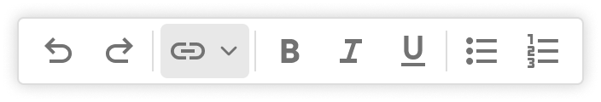
- When clicking on “Attribute to Source” the following menu appears:
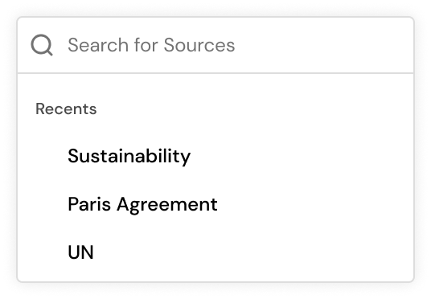
- The user can select the most recent projects (limited to 3 on display).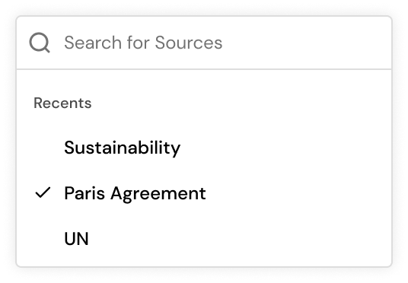

- Or use the search bar to search and select a source.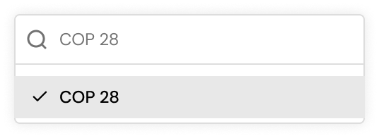
- The selected text should then reflect the attribution with a footnote (blue) and underline the text.
- Upon hover, the source should be displayed in a small window,

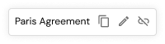

- The user can interact with this window by:
  - Copying the link to clipboard
    - 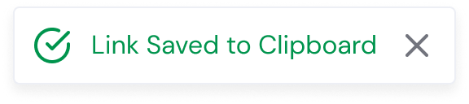
  - Edit the attribution
  - Un-attribute or unlink the attributed text from the source
    - 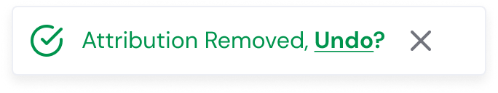

- At the time of attribution, a footnote should also be added to the bottom of the page
  - The user can click on the expand button to expand the source card on the right to view its content.
  - We will have the scroll only when the standard height of the document does not fit on the screen height fully
  - The following tooltip should provide feedback of the user as to the attributions success
    - 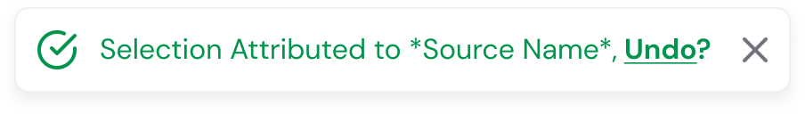

- Un-attribute or unlink the attributed text from the source
  - To remove attribution the user clicks on the following button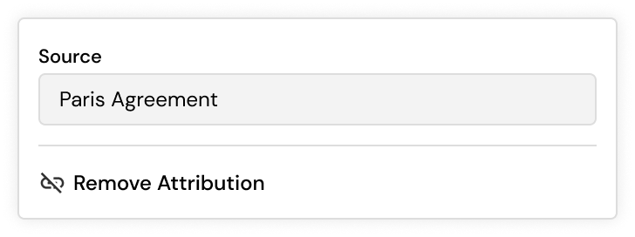

- Once removed, the user is free to search for and select another source as before
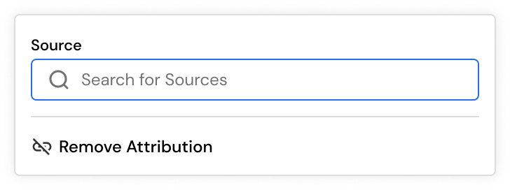

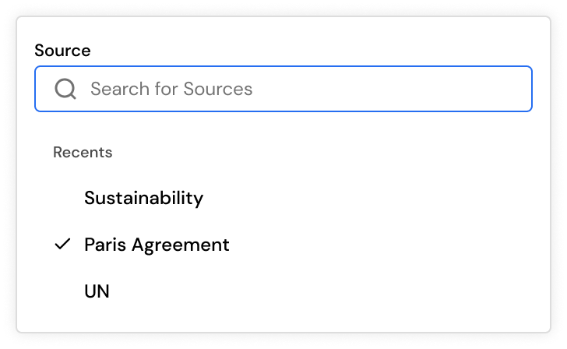

- These attributions will also take effect in the source card themselves.
- If a source has been used for an attribution, the following dropdown will be visible on the card. 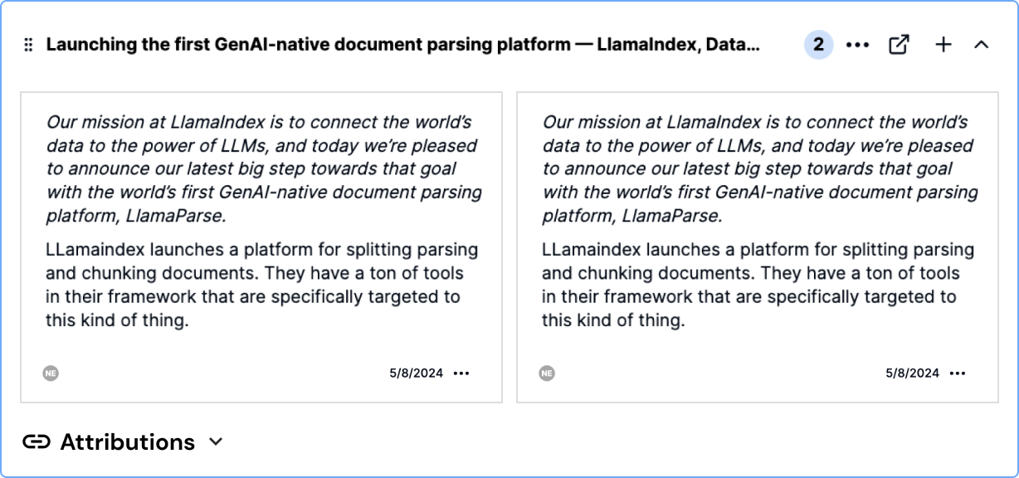

- When clicked, the dropdown will display the text (attributions) which have be used on the document:
  - If the text exceeds one line, there should be a “See more” button as with the annotations, which allows the user to expand and view the entire text. To collapse, the user can click on “See less”.
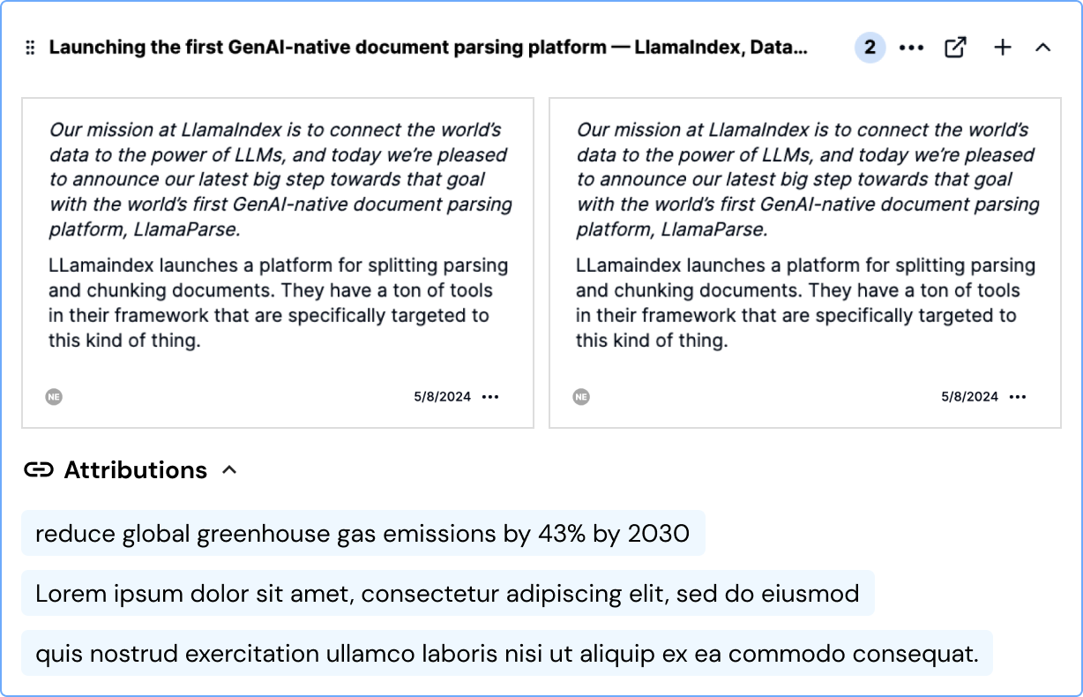

- When hovering over the attributions, the user can un-attribute or unlink the attributed text by clicking on the unlink button (on the right part?):
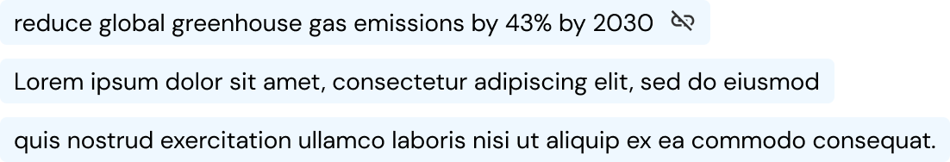

- When removed, the user is prompted to confirm the action with the following dialog box
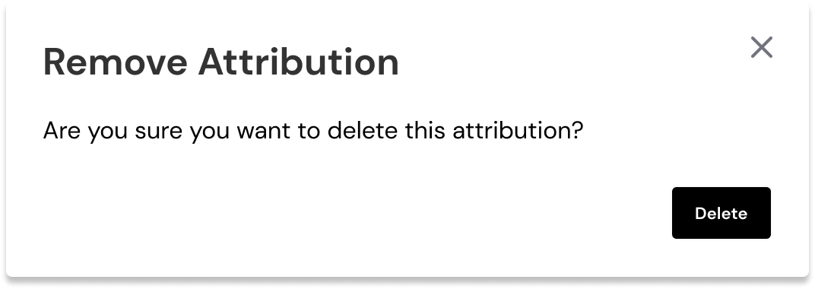

Open Questions
- To remove or unlink attributions from source cards, the unlink button will be displayed upon hovering over the attribution. Let's see if users have trouble with it. We can make it always visible if so.
- More than one source may be selected for the attribution.
- Any text can be part of several attributions
- Naming Attributions e.g. giving a title to the attributed text.

Out of Scope
- More than one source may be selected for the attribution.

